**Final Project Basic Analysis: Effects of Stay-at-Home Orders**

Rebecca Leu, Brandy Davis & Ronel Sylvester

ALY6110: Data Management and Big Data

Dr. Reza Sadoddin

Feb 16, 2021

Abstract

In this analysis, we would like to analyze how the stay-at-home-order (SaH) might have played a role on certain variables such as *Hiv prevalence Rate, Housing, etc.* Due to the nature of the dataset, there are some columns that will not cooperate well with Tableau’s analysis structure, so we had to be selective in our variable and metric choosing. We have also decided to specifically analyze the states of California, Washington, and Idaho to help us understand the data in a narrower manner. The dates range from the mid-january 2020 until early-December 2020.

**Analysis of STD rates during lockdown**

The first analysis we wanted to dive into was in regards to how the SaH order might have had an effect on HIV rates across California, Washington, and Idaho. With the data at hand, we first took a look at the columns that would help us find insights about these metrics which are as stated: *Num Hiv Cases, Hiv prevalence Rate, State, County, and Population Density per Sqmi*. The *Num Hiv Cases* column is calculated in a way that cumulatively adds up. For example, if on January 21st there were 5 chlamydia cases in a certain county and on January 22nd, there were 3 chlamydia cases in that same county, the data reports January 22nd as having 8 chlamydia cases since it cumulatively adds up the previous dates. This made it quite hard to work with this column in Tableau because we can neither use the SUM nor the AVERAGE function. Therefore, we decided to stick with the column that pertains to the rate of HIV cases since these data points are calculated only for a particular date.

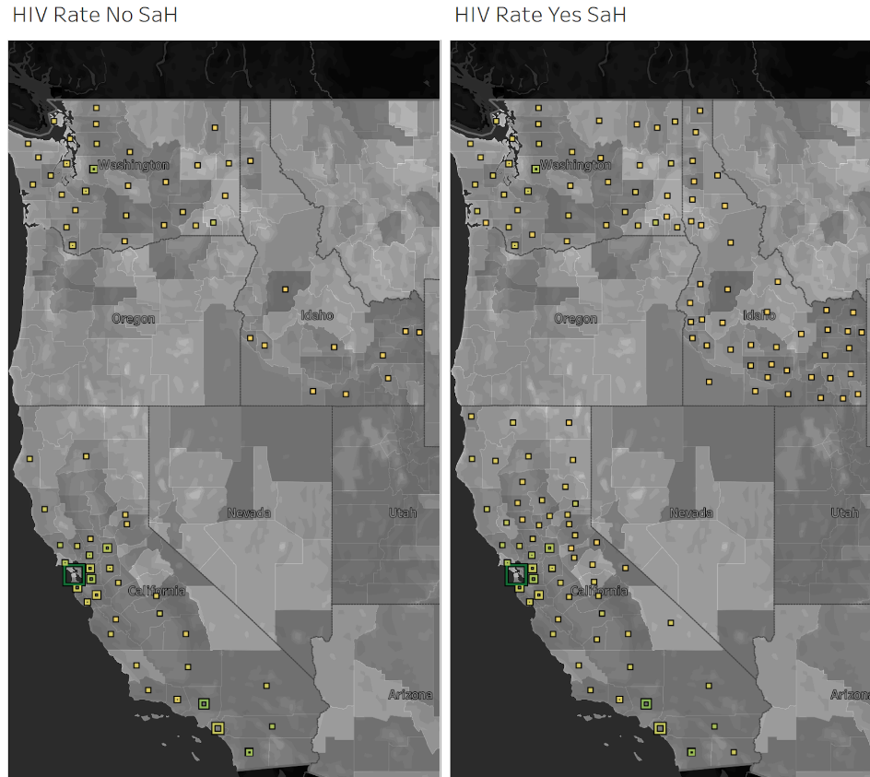

The above dashboard gives us insight as to how the average rate of HIV cases within California, Washington, and Idaho changed before and after stay-at-home orders were in place. The darker color represents a higher average rate of cases and the square size depicts the population density of the specific county. The big and dark green square in the middle of California depicts San Francisco which makes logical sense. San Francisco has a highly dense population which stands at 18K people per square mile. The grayscale background on each county represents the average household size and if you look closely at San Francisco’s color, it is a lighter gray shade which signifies that a good portion of people who live in SF are more or less singles or just couples without kids. The population of singles in SF may also play a significant role in the higher STD rate. Married couples will mostly have sexual relations with the same person and singles will most likely have sexual relations with different people which allows for a higher chance of transmitting/receiving an STD.

We can also see that there is not too much of a difference between the maps when it comes to the stay-at-home order being in place or not. The only difference that seems to come about is that there are more counties that have reports for their STD rates when we add the SaH in place dates. When diving deeper into the data we found that the amount of times a county reported their STD rate, was quite low unfortunately. Each county would have also reported changes at different dates, so it is hard to know the true nature of the STD rate over time. However, even with the low reporting of HIV rates, we can still see the average rate lowering down in the state of California from the following graph. This is simply a correlation so we will have to do a deeper statistical analysis to find out if there is any causation involved. Blue is SaH not in place while Green is SaH in place and the dates are from Jan 2020 - Dec 2020.

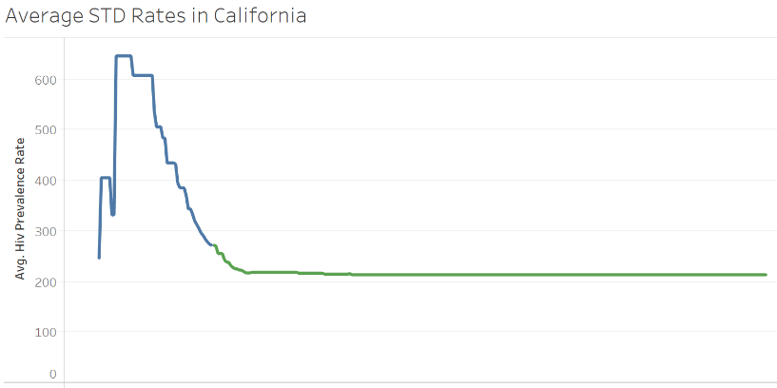

**Mental Health Analysis**

Additionally, we wanted to see how the SaH orders might influence mental health. The dataset we chose had a few different variables to analyze regarding mental health: percent of frequent mental distress, Average number of mentally unhealthy days and average suicide rate age adjusted.

Figure 1 shows the average percent of frequent mental distress by month. The blue line represents during a time that stay-at-home orders were not in force and the orange line represents when they were. It appears that whether a SaH order was in effect or not in your state, percent of mental distress went from around 11% up to almost 13% after news of the virus and its movement into the united states became apparent. For the states that did not have a stay-at-home order, the rate went down slightly in the continuing months rounding out at about 12% while states that did have a SaH order continued to climb, rounding out at over 13%.

Figure 1.

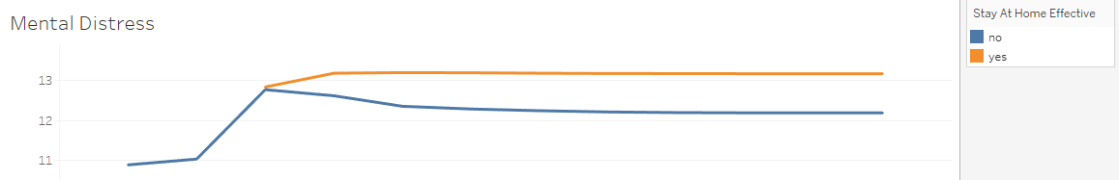

Narrowing in on the states we wanted to focus on, Figure 2 shows the average number of mentally unhealthy days and how they increased over the months.

Figure 2.

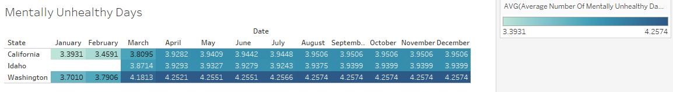

Based on these numbers it appears that the states of California and Washington had an uptick of about a half day increase on average of mentally unhealthy days once COVID-19 hit the US. It appears Idaho didn’t keep this metric before march of 2020 so it is hard to make any conclusions about that states data.

Figure 3.

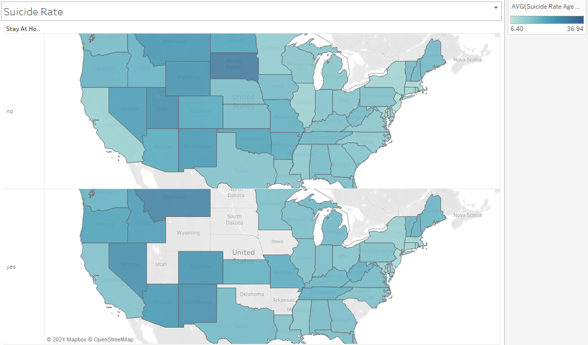

Finally, we wanted to look at suicide rates as a nation. This map in Figure 3 shows the suicide rates by state. The top map shows what this rate was before a SaH order was mandated and the bottom shows the rates during the SaH orders. This map had a bigger impact when it is used in tableau interactively by scrolling over the states. Figure 4 (below) is an alternative graph used to show the increase in suicide rates after SaH orders went into effect for the states we are focusing our analysis on. Each state had an increase in the suicide rate of about 4% after the SaH orders took place.

Figure 4.

